**Brand Personality**

**Meaning,**

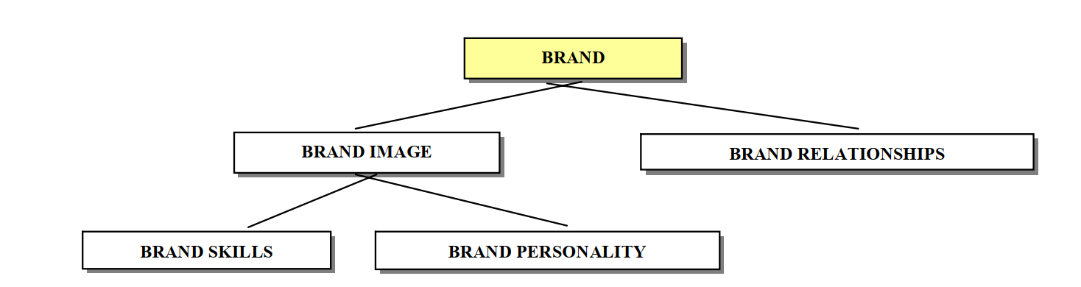

It is a comprehensive concept, which includes all the tangible and intangible traits of a brand, like, beliefs, values, prejudices, features, interests, and heritage. Brand Personality is a set of human characteristics associated with a brand. In general, it expresses how the brand behaves.

A brand in a customer’s mind is a complex network of associations. Biel proposes that these associations can be of two types: hard and soft.

A brand personality makes it unique. Like human personality, a brand personality is both distinctive and enduring and is built over a period of time. It refers to the outcome of all the consumer’s experiences with the brand.

It may include a brands gender, age, socio-economic class, psychographic, emotional characteristics.

Biel’s distinction between brand skills, brand personality and brand relationship is shown below-

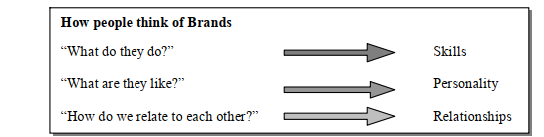

Example: IBM is ‘older’ while Apple is ‘younger’

India Today is ‘old-fashioned’ while Outlook is ‘trendier’

Coke is ‘conforming’ while Pepsi is ‘irreverent’

A brand personality makes it unique. Like human personality, a brand personality is both distinctive and enduring and is built over a period of time. It refers to the outcome of all the consumer’s experiences with the brand. In other words, the brand’s personality is the weighted average of previous impressions. In consumer’s mind, these impressions merge to form an overall concept of what to expect from brand.

Brand personality is seen as a valuable factor in increasing brand engagement and brand attachment, in much the same way as people relate and bind to other people. Brand Personality is eagerly searched by brand strategists and researchers to find out differences in responses by different consumers provide useful insights.

working ,

Example:

1. Users of a product will perceive a brand different from non-users

In essence, it can be said that ‘Personality traits are what the brand will live and die for’.

Example:

1. Axe- Seduction, masculinity, individuality, unconventionality

2. Levi’s -Rebellion, sensuality, being cool

3. Spinz -Young, Modern, Active, Outdoor, Cheerful, Friendly

Types of brand personality

Examples:

The concept of brand personality is useful because of following reasons. It:

1. enriches understanding

2. helps gain an in-depth understanding of consumer perceptions of and attitudes towards

the brand

3. can provide more insight than is gained by asking about attribute perceptions

4. contributes to a differentiating identity

5. can differentiate brands especially where brands are similar in product attributes

6. in fact, can define not only the brand but the product class context and experience.

|  |
| --- |
| *Example:* Mercedes vs BMW Clinic Plus vs Pantene |

1. Guides the communication effort

2. Communicates the brand identity with richness and texture

3. If the brand is specified only in terms of attribute associations, very little meaningful

guidance is provided.

|  |  |
| --- | --- |
| *Example:* Is Nike shoes or sports, performance and attitude?Creates brand equity | 1. |

2. Builds long-term brand equity

3. Differentiates the brand and makes it distinct from other competitive offerings

4. Serves as a powerful relationship device

**Self Assessment**

Fill in the blanks:

10. ……………….is a set of human characteristics associated with a brand. In general, it

expresses how the brand behaves.

11. Brand personality is seen as a valuable factor in increasing ……………and brand attachment,

in much the same way as people relate and bind to other people.

***Brand Personality:*** It is a comprehensive concept, which includes all the tangible and intangible traits of a brand, like, beliefs, values, prejudices, features, interests, and heritage.

How do consumers around the world learn about a brand’s personality? In some cultures, there are many other sources from which consumers derive their perceptions of brand personality. Although advertising still plays a dominant role in developing the personality for some brands in some cultures, there are many other sources from which consumers and customers derive their perception of brand personality. This is illustrated in a schematic picture below.

